Communications & Messaging Programme
Mental Health, Community & Social Care Work Stream
Phase 1 Development

SAP Business Communications Specification (W5)

Amendment History:

Version | Date | Amendment History
V0.1 | 8/9/03 | First draft for comment
V0.2 | 9/9/03 | JW - Amendments following initial review
V0.3 | 17/9/03 | Template amendments plus new scenario wording
V0.4 | 25/09/03 | Amendments prior to external review.
V0.5 | 6/10/03 | Updated with reviewer comments.
V0.6 | 27/11/03 | Incorporating revisions from W3, V0.9 and input from the NHSIA Data Dictionary team.
V0.7 | 4/12/03 | Revision to remove references to ESCR as a method of integrating social care information.
V0.8 | 6/1/04 | Revised with comments from Chris Dunstan, Beverley Castleton and the NHSIA SAS Dataset team
V0.9 | 9/2/04 | Updated with input from Data Dictionary team
V0.10 | 26/2/04 | Updated with CRM comments
V0.11 | 3/3/04 | Minor amendments.
V0.12 | 21/3/04 | Incorporating comments from Penny Aitchison
V0.13 | 24/3/04 | Corrections follow review of the above (JW)
V014 | 25/3/04 | Note added on P14 re on-going work around SAP care coordinator management
V1.0 | 26/03/04 | Approved
V1.1 | 16/04/04 | Draft – updated to use ‘Care Event’ message & remove SAP Care Coordinator messages
V1.2 | 06/05/04 | Further clarification around how the SAP Assessment message data maps to the Provision of Care ‘Care Event’ message
V1.3 | 07/05/04 | Comment added re: care event and SAP on page 17
V2.0 | 07/05/04 | Approved
V2.1 | 09/06/04 | Further refinement of harmonisation with PSIS Query and POC Care Event messages
V2.2 | 15/6/04 | Incorporating further comments from Els Briscoe and John Weight
V2.3 | 18/6/04 | Cardinality changes and final amendments to Assessment Transmission message.
V3.0 | 23/6/04 | Approved

Approvals:

This document requires the following approvals.

Name | Signature | Title | Date of Issue | Version
Max Jones |  | Head of Communications and Messaging | 18/6/04 | 2.3
Margaret Baldock |  | Programme Manager | 18/6/04 | 2.3

Document Location

This document is only valid on the day it was printed. Please contact the Document Controller for location details or printing problems.

This is a controlled document.

On receipt of a new version, please destroy all previous versions (unless a specified earlier version is in use throughout the project).

© Crown Copyright 2004

Unauthorised copying, distribution, renting, lending or communicating to the public of all or a substantial part of any Crown Copyright material is prohibited. Licences for the use of Crown Copyright material are available from Her Majesty's Stationery Office, at http://www.hmso.gov.uk (click on 'Click-Use licences').

All trade marks and logos are the property of their respective owners. The use of any trade mark or logo without the prior written permission of the relevant owner is prohibited.

Contents

1. Purpose 7
2. Identify SAP care co-ordinator 7
2.1. Description 7
2.2. Clinical Scenario 7
2.3. Activity diagram 8
2.4. Business Communications 8
2.4.1. SAP Care Co-ordinator Search Request 9
2.4.2. SAP Care co-ordinator search result 10
3. Appoint SAP care co-ordinator 11
3.1. Description 11
3.2. Clinical Scenario 11
3.3. Activity diagram 12
3.4. Business Communications 12
3.4.1. SAP Care Co-ordinator Appointment 12
4. Review existing Assessments 14
4.1. Description 14
4.2. Clinical Scenario 14
4.3. Activity diagram 15
4.4. Business Communications 16
4.4.1. Assessment Listing Search Request 16
4.4.2. Assessment Listing Search Response 17
5. SAP Assessment Transmission 18
5.1. Description 18
5.2. Clinical Scenario 18
5.3. Activity diagram 19
5.4. Business Communications 19
5.4.1. Send SAP Assessment to PSIS 19

Glossary

The following abbreviations are used throughout this document

SAP Single Assessment Process
SAP CC Single Assessment Process Care Coordinator
H&SCP Health &/or Social Care practitioner
PSIS Patient Spine Information Services
PDS Patent Demographic Services
TMS Transaction Messaging Service – use to route messages to and form the PSIS, PDS and local systems
NHSD Directory service holding details of all H&SCPs.

Local Clinical System Throughout the document this title represents those systems used by H&SCPs to support their day to day recording of care provided to service users. This will include local SAP IT solutions, GP systems, community and acute clinical systems which hold relevant data and support functions within the overall SAP process.

Common Assumptions

- All H&SCP staff will be included on the NHSD (Directory Service) in a timely and accurate manner.
- All staff and their host organisations which undertake the SAP CC role will have an appropriate entry in the NHSD.
- H&SCP staff working from social care locations will be provided with an appropriate level of access to the ICRS (PDS, PSIS and NHSD).
- H&SCPs working in the health environment have enquiry access to ICRS via their local clinical systems.
- The messages specified in this document do not address the local need for SAP tools or integration between services in a specific locality.
- Care Plans including actions by carers and others outside of the health/social care environment for example voluntary organisations will be recorded on the LA or health system but actioned using existing manual processes for example letter or email.
- The term SAP care co-ordinator is common to all systems and is used as the national standard for this role.
- H&SCP staff can have multiple roles depending upon the service they are providing and this can be recorded against the service user record on PSIS.
- All messages containing H&SCP information will contain a unique identifier for the H&SCP. Upon receipt by the local system an enquiry upon the NHSD (message to be delivered by another workstream) will provide name, location and contact information for inclusion in the viewed message.
- All new entries or updates to the patient demographic record will be handled via the PDS standard transaction set and do not form part of this work stream.

Business Communications Transferred

Since the commencement of the SAP message development the overall Communications and Messaging programme has undertaken several generic projects which upon examination now address the majority of the messages originally deigned to be SAP specific. The remaining message, Notification to SAP Care Co-ordinator, at this time utilises functionality which is not delivered in the CRS and has therefore been removed from this document.

Message | Transfer Destination | Note
Current Care Worker Contact Details | Care relationship functionality not supported in NCRS Phase 1 R2 | Removed from earlier version of W5
Referral Transmission | Provision of Care W5 reference NPFIT-NDA-COM-RZ-0299 | Removed from earlier version of W5
Referral Decision | Provision of Care W5 reference NPFIT-NDA-COM-RZ-0299 | Removed from earlier version of W5
Identify SAP Care Co-Ordinator | Care relationship functionality not supported in NCRS Phase 1 R2
Appoint SAP Care Co-Ordinator | Care relationship functionality not supported in NCRS Phase 1 R2
Review Existing Assessments | PSIS Query W5 NPFIT-NDA-COM-RZ-0303
SAP Assessment Transmission | Provision of Care W5 reference NPFIT-NDA-COM-RZ-0299 | See PoC table extract in section 5.4.1
Notification to SAP Care Co-ordinator | Care relationship functionality not supported in NCRS Phase 1 R2 | Removed from this version.

Purpose

- This document describes in detail the message content of each of the business communications outlined in the in the SAP Detailed Business Analysis report.
- It forms the deliverable for each Work Stream Domain – Business Communication definition and refinement stage (W5) in accordance with the Communications & Messaging Programme Development methodology
- It lists the data items, their inter-relationships, grouping, data typing, validation rules and coding (where appropriate)
- It lists, at a data level, any issues that have been identified that would hinder development and/or implementation
- Provides a means to communicate the proposed message content to the Programme’s Technical (message development) team to enable them to form the required HL7 message constructs; and similarly to the suppliers that will have to build them

Identify SAP care co-ordinator

The ability to “Identify the SAP Care Co-ordinator” is dependent upon Care Relationship functionality in the NCRS that is not available in Phase 1. Therefore the two messages specified in section 2.4 cannot be supported in Phase 1 Release 2.

Description
The SAP co-ordinator is at the hub of all care delivered to the service user and is appointed prior to the undertaking of an Overview Assessment. As part of the SAP rollout all participant organisations are required by 1st April 2004 to have SAP co-ordinators identified and in post.

This process requests from and receives into the local clinical system, from the PSIS, the name and other pertinent information for the appointed SAP care co-ordinator for the service user.

Actions Preceding: Clinical or administrative requirement to contact SAP Care Co-ordinator.
Actions Post: Contact the SAP Care Co-ordinator to fulfil requirement.

Clinical Scenario
The District Nurse attending Betty is taken ill and a replacement calls to her home. Upon arriving Betty is agitated about the future care plan and the possibility of going into a home. The District Nurse cannot factually assuage this concern therefore there is a need to contact the Care Co-ordinator for information and support with handling Betty’ concerns on this day. At the next available opportunity the District Nurse logs on to her local clinical system and requests the identity of the SAP Care Co-ordinator.

Please note that the co-ordinator may have this role for several individuals who may be receiving care from one or more health, social or voluntary agencies. The appointment is mandatory for a service user with multiple needs under SAP guidance.

Activity diagram
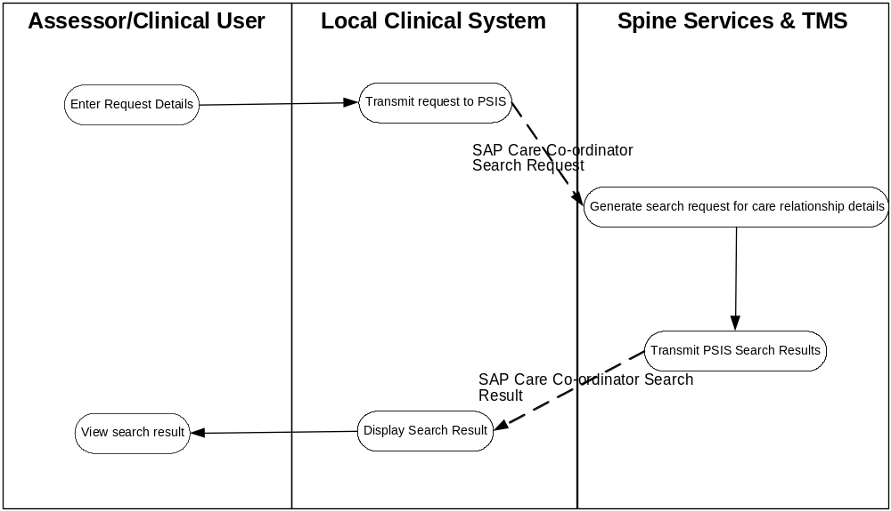

Fig: Identify SAP care co-ordinator

Business Communications
- SAP Care Co-ordinator Search Request
- SAP Care Co-ordinator Search Results

SAP Care Co-ordinator Search Request
Purpose

To request the identity of the H&SCP who has the SAP care co-ordinator role for a given service user

Communication Type

Request

Sending System

Any local health or social care system

Trigger Event

Entry of request details on local system.

Sending Role

Service user has been identified along with their NHS number

Receiving system

TMS

Post-receipt activity

Generate request for SAP care coordinator details from PSIS.

Business Communication Content
The required Care relationship functionality is not available in NCRS Phase 1 Release 2 so this communication cannot be supported.

SAP Care co-ordinator search result

Purpose

To return the identity of the SAP Care Coordinator to the requesting system

Communication Type

Response

Sending System

PSIS

Trigger Event

TMS retrieval of the SAP Care coordinator details for the specified service user

Sending Role

Receipt of the request message 3.4.1

Receiving system

Local health or social care system

Receiving role

Display of information retrieved for review via, and potential storage on, the local system.

Business Communication Content

The required Care relationship functionality is not available in NCRS Phase 1 Release 2 so this communication cannot be supported.

Appoint SAP care co-ordinator

The ability to “Appoint SAP Care Co-ordinator” is dependent upon Care Relationship functionality in the NCRS that is not currently available in Phase 1 Release 2. Therefore the message specified in section 3.4 cannot be supported.

Description
The SAP co-ordinator is at the hub of all care delivered to the service user and is appointed prior to the undertaking of an Overview Assessment. As part of the SAP rollout all participant organisations are required by 1st April 2004 to have SAP co-ordinators identified and in post.

This process represents the decision as to who will perform this role and the subsequent transmission of this decision to the PSIS, via the local clinical system.

Actions Preceding: Decision that the service user’ needs are complex and require assessments beyond the Contact Assessment.
Actions Post: Assessment(s) are undertaken and notified to PSIS.

Clinical Scenario
Betty, a 72 year old lady, living alone in semi-detached house was referred to the district nursing service following admission to hospital for a stroke. She had been in hospital for 9 weeks. During this time she had developed a grade 3 pressure sore to her sacrum which required dressing. Betty had been diabetic (type II) for approximately 8 years. Her blood glucose had been stable at around 10mmols whilst in hospital.

Betty was widowed 3 years ago she had 2 children, both of whom worked full-time and had teenage children. Her son was rarely able to visit and her daughter visited fortnightly until recently. The stroke had left Betty with a mild right hemiplegia. She was mobile independently with a stick. Her daughter (Valerie) was now visiting at least weekly and fetching her mother’s shopping. District Nurse was also visiting 3 times per week and required information on who else had contact with the service user in order to confirm the level of input required.

The district nurses reduced their visits from 3 times each week to redress the sacral sore to weekly over a period of 8 weeks. Recently, her diabetes had become less well controlled on oral hypoglycaemics. At around this time Betty had a fall. As a result of which she sustained a superficial laceration to her right hand and right shin. Betty’s general ability to cope with the current level of support was becoming a problem. She was also less confident when mobile and had had a few “accidents” when going to the toilet. Her daughter now had to cope with increasing amounts of washing and dependence, she had increased the frequency of her visits to daily, calling in either before or after work (she worked shifts at a residential home 10 miles away).

On the next visit to see Betty, the district nurse noticed the lacerations that Betty had sustained. Betty’s account was vague and the district nurse was concerned. She telephoned Betty’s daughter, Valerie expressed concern about her mother’s health and in particular, her general ability to cope at home. Since the fall earlier that week Valerie had been trying to persuade her mother to accept more help, but Betty thought that they were managing “just fine”. However, Valerie now expressed concern at the long term manageability of the situation. She was also concerned that her mother was forgetting to take her medication on occasions.

Betty’s general situation now meant that she had long-term complex health and social needs. The District nurse in agreement with Betty and Valerie, made a referral to Social services to undertake an overview assessment of Betty’s needs. As a precursor to the assessment a SAP Care co-ordinator has to be appointed, in this case from social care. A telephone conference was held and an agreement reached on a suitable individual.

Activity diagram
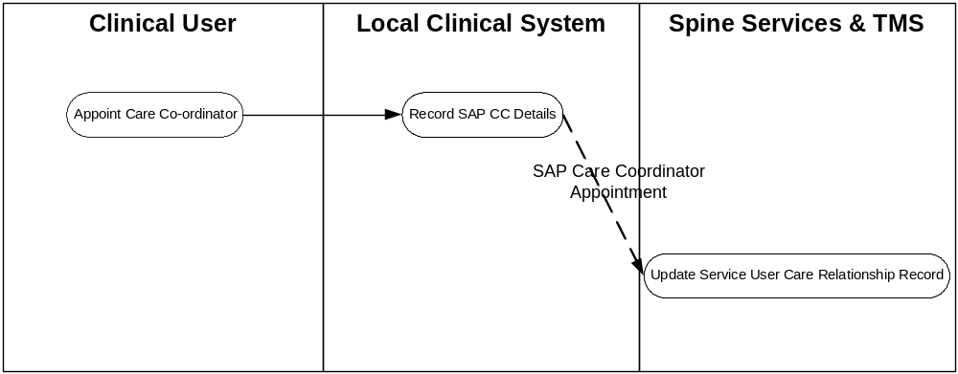

Fig: Appoint SAP care co-ordinator

Business Communications
- SAP Care Co-ordinator Appointment

SAP Care Co-ordinator Appointment
Purpose

To notify the PSIS that an individual, has been appointed to the role, of SAP Care Coordinator for a specific service user.

Communication Type

Notification

Sending System

Any local health or social care system

Trigger Event

Completion of the recording of the appointment of SAP Care Co-ordinator and registration on local clinical system.

Sending Role

Service user has been identified along with their NHS number and staff member undertaking the role is known.

Receiving system

PSIS

Post-receipt activity

Update service user care relationship record on the PSIS.

Business Communication Content

The required Care relationship functionality is not available in NCRS Phase 1 Release 2 so this communication cannot be supported.

Review existing Assessments

The ‘Review Existing Assessments’ requirement is now supported by the PSIS Query message set - reference NPFIT-NDA-COM-RZ-0303. Please refer to the Business Communication Content sections below for more detail.

Description
The extraction and review of all assessments lodged on the PSIS for the service user. In the SAP context, it would be used by a health or social care professional to review previous service user SAP assessments prior to an encounter where further assessments or changes to current treatment may be considered.

Actions Preceding: Decision to review existing assessments to inform the next decision.
Actions Post: Undertake further assessments and/or follow up on existing documents.

Clinical Scenario

Prior to undertaking any further assessments the SAP Care Co-ordinator reviews existing assessments by logging on to the local clinical system and requesting a listing of all assessments undertaken to date. Through this she hopes to minimise time and duplication of effort. The response from PSIS indicates that only a contact assessment has been undertaken within the timeframe and therefore an overview assessment can proceed.

Activity diagram

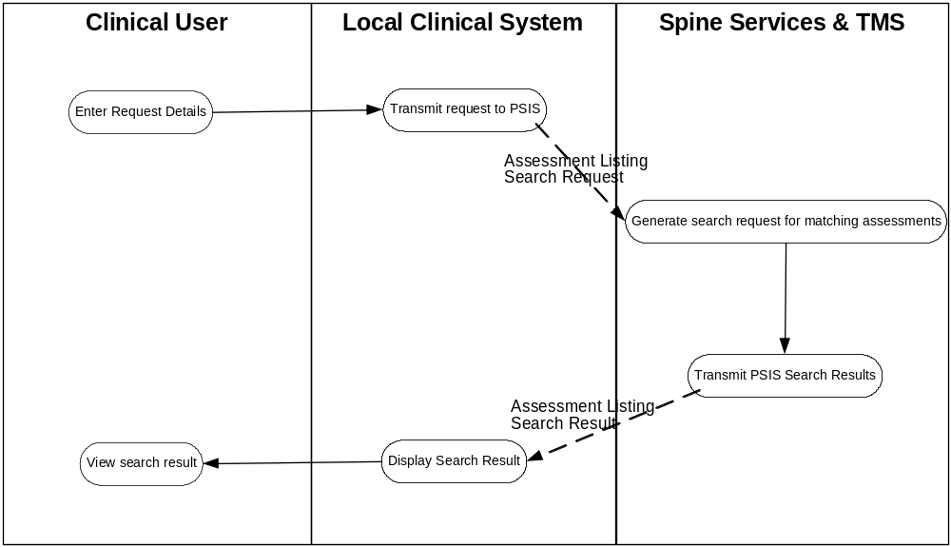

Fig: Assessment Review

Business Communications
- Assessment Listing Search Request
- Assessment Listing Search Response

Assessment Listing Search Request
Purpose
To request a comprehensive, time limited, listing of all assessments undertaken for the service user.

Communication Type
Request

Sending System
Any local health or social care system

Trigger Event
Entry of request details on local system.

Sending Role
Service user has been identified along with their NHS number and a suitable time frame for enquiry.

Receiving system
PSIS

Post-receipt activity
Generate request for assessment listing details from PSIS.

Business Communication Content
A request for a list of previous SAP assessments can be made using the PSIS Query Summary ‘Care Event’ view; requesting systems will have to filter out the events that are SAP Assessment using the ‘Care Event’ type data item. At the time of writing the Care Event type for a SAP Assessment is undefined; if however, the Care Event type definitions turn out to be at high level and insufficiently explicit, then a simple PSIS Query can be used to pull back all ‘Procedure’ care record elements (CREs) and then filtered using Procedure Type= ‘SAP Assessment Procedure’ SNOMED term. The PSIS Query ‘Follow links’ option must be set to ensure that the complete set of SAP statements are returned. An alternative approach would be to use the PSIS Event List query for the required type of ‘event’ and then use PSIS Event query to retrieve each set of assessment details in turn.

Please refer to PSIS Query Business Communications Specification (W5) reference NPFIT-NDA-COM-RZ-0303 for details.

Assessment Listing Search Response

Purpose

To return the assessment listing to the requesting system

Communication Type

Response

Sending System

PSIS

Trigger Event

PSIS retrieval of the assessment listing details for the specified service user

Sending Role

Receipt of the request message 4.4.1

Receiving system

Local health or social care system

Receiving role

Display of information retrieved for review via, and potential storage on, the local system.

Business Communication Content

The response data is as per the chosen PSIS Query option. Please refer to PSIS Query Business Communications Specification (W5) reference NPFIT-NDA-COM-RZ-0303 for details.

SAP Assessment Transmission

The ability to record individuals as part of the care team for a service users and the functionality to support automated notification to these individuals via TMS will not be available. Therefore the “Notification to SAP Care Co-ordinator” has been deleted from this document.

Description
Once completed a record of the SAP assessment, whether a Contact assessment or the whole or part of an Overview assessment, being undertaken needs to be placed on the PSIS and a notification sent to the SAP care co-ordinator for Overview Assessments.

Actions Preceding: Completion of the assessment, including any updates to the patient demographic record on PDS (outside of scope), in whole or part by suitably qualified staff.
Actions Post: Creation and dissemination of all required referrals plus notification to SAP Care Co-ordinator if appropriate.

Clinical Scenario
The overview assessment was undertaken by the Social worker as SAP coordinator, with contributions to assess health needs from the district nurse & GP. Both Betty’s and Valerie’s needs and wishes were taken into account. Valerie could not sustain her current level of support to her mother. This was compounded by pressures at home, her son had his GCSE’s in 6 weeks and they were going on 2 weeks holiday abroad following this. Her mother’s situation had deteriorated such that she felt that they could no longer provide the care and support that she needed. Betty was very concerned to stay in the home she had lived in since she was married.

Health:
The deterioration in Betty’s condition recently, led to the district nurse increasing her visit to twice daily for 3 days to monitor blood glucose levels and then to 3 times per week to dress the lacerations as well as the sacral sore. She also planned to undertake a continence assessment and arranged for a commode to be delivered, since Betty was now unable to get upstairs to the toilet that she had been using. District Nurse entered information into the computer upon return to base for the appropriate domains in the Overview Assessment, particularly section6.

Social:
The social worker visited within 48hours to assess social need. She identified that Betty was managing to wash but required support to bathe each week. She suggested meals on wheels, but Betty wasn’t keen to have these. Discussions with Valerie led to the purchase of a small freezer and the social worker arranged for frozen meals to be delivered. She offered Betty day care every Thursday, but Betty wasn’t keen to be with “all those old people” and declined. It was also arranged that a care worker would come in each morning to help Betty get her breakfast and to empty the commode. Social worker updated the Overview Assessment Domains 4 and 5 through the social care computer system.

The district nurse found Betty’s diabetes to be poorly controlled. It appeared that she was taking her medication inconsistently. Liaison with the GP and local chemist set up a weekly dispensed medication system. Which improved her compliance with taking her medication as prescribed and the control of her diabetes. The ability to easily obtain appropriate, regular meals also helped this situation. Over a period of 2 weeks her blood glucose levels stabilised.

The district nurse found that the incontinence was due to a combination of neurological and functional causes. Changes to Betty’s clothing to make it easier to adjust to go to the toilet and the supply of pads for light to moderate incontinence enabled Betty to manage her incontinence.

Activity diagram

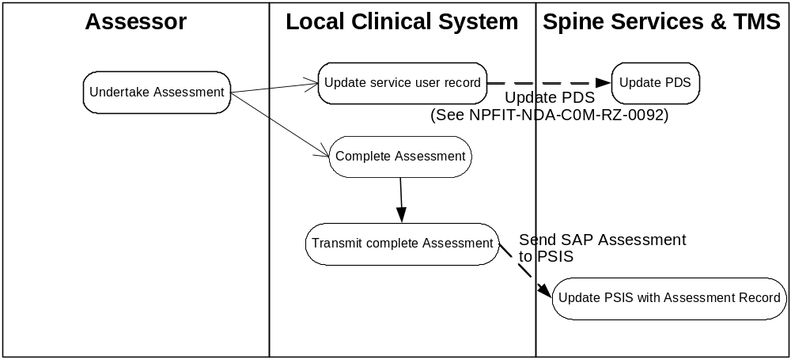

Fig: Assessment Transmission

Business Communications
- Send SAP Assessment to PSIS - reference NPFIT-NDA-COM-RZ-0299 – Provision of Care ‘Care Event’ Message’
- ‘Update PDS (as a result of assessment) – reference NPFIT-NDA-COM-RZ-0092 Personal Demographic Service

Send SAP Assessment to PSIS
Purpose

The transfer a record of the assessment to the PSIS

Communication Type

Notification

Sending System

Local system belonging to any agency undertaking SAP assessments, could be Social Services, GP or other Primary Care system

Trigger Event

- Completed entry of the Contact Assessment and collation of information for sending
or
- Completed entry of part or all of the Overview Assessment and collation of information for sending

Sending Role

- Demographic detail has been verified (this may involve updates to the PDS – not illustrated)
- Service user NHS number retrieved

Receiving system

PSIS

Receiving role

Transfer of SAP Assessment details to the service user record held on the PSIS.

Business Communication Content
The SAP Assessment Transmission message is to be provided as a Care Event Report using the generic Provision of Care W5 reference NPFIT-NDA-COM-RZ-0299.
The data sets, shown overleaf, will be required to provide the functionality identified through the SAP business analysis.

Data Sets for Provision of Care | PoC  Care Event report | Required for SAP Assessment Transmission
Sender details | √ | √
Recipient details including “copied to” | √
Service user Demographics | √ | √
Service User Legal Status | √
Service User Personal Preferences | √
Referral/transfer Requirement
Transport
Discharge
Care Event Information | √
Health and social issue | √ | √
Diagnosis | √
Procedures | √ | √
Findings | √
Outcomes | √
Care plan | √
Planned procedures/care events | v | √
Goal | √
Family History | √
Allergy | √
Alert | √
Risk | √
Social History / Circumstances | √
Functioning and Well-being | √
Medication Record | √
Response to Transfer Request
Cancellation of Transfer Request
Response to Cancellation of Transfer Request
Please note that:
- All issues noted in, or following, these tables relate solely to the SAP Assessment Transmission message
  - 1. Sender Details

Level | Group / Item name | Definition | Example | Representation | Cardinality | Constraints & Dependencies | Default value | Null required | Outstanding Issues
1 | Sender | Group Name |  |  | 1..1
 | Choice of
1.1 | PERSON IDENTIFIER | Unique ID FOR H&SCP AS HELD IN THE NHSD. |  | UID – as per SDS | 1..1
1.2 | PERSON role profile ID | H&SCP ROLE profile as defined in the Spine Directory Services | . | UID as per SDS | 1..1 |  | Role as recorded in H&SCP directory
 | OR
1.3 | Organisation Identifier | Unique identifier for the SENDING organisation OR DEPARTMENT FOR H&SCP |  | as per SDS | 1..1
2. Service User Demographics

Level | Name  Item/Group | Definition | Example | Representation | Cardinality | Constraints & Dependencies | Default value | Null required | Outstanding issues
2 | Patient identifier | Unique identifier for a patient |  |  | 1..1
2.1 | NHS NUMBER | NHS NUMBER- | 01283746 | UUID  DATA DICTIONARY STANDARD | 1..1

Note; Full demographics will be brought forward by standard enquiry upon the PDS.

3. SAP ‘Procedure’
The SAP Assessment Procedure is recorded in item 3.1, the procedure qualifier at item 3.3 then records whether the assessment is a Contact or an Overview Assessment. If it is an Overview Assessment then between 1 and 9 individual assessment domains may be recorded.

Level | Group / Item name | Description | Example | Representation | Cardinality | Cross-field Constraints | Default value | Null type | Outstanding Issues
3 | Procedure ID | Unique identifier for this procedure for a patient |  | UUID | 1..* | Cardinality is 1..1 for contact Assessment
3.1 | Procedure code | Snomed coded description of the actual investigation/test/obs etc undertaken | SAP Assessment Procedure | Coded with equivalents | 1..1 |  |  | NAV
3.2 | Procedure status | Description of the status of the procedure | Completed, in progress | Coded with equivalents | 1..1 |  | A default may be needed
3.3 | Procedure qualifier | Overview Assessment Domain name | Contact Assessment or Overview Assessment with one of 9 options:  - Domain 1 Person’s Perspective  - Domain 2 Senses  - Domain 3 Immediate environment and resources  - Domain 4 Personal Care and Physical Well Being  - Domain 5 Clinical Background  - Domain 6 Mental Health  - Domain 7 Safety  - Domain 8 Relationships  - Domain 9 Disease Prevention | Coded with equivalents | 1..*
Level | Group / Item name | Description | Example | Representation | Cardinality | Cross-field Constraints | Default value | Null type | Outstanding Issues
3.5 | Date/time performed | Date/time that patient had procedure |  | Date/time | 0..1
Choice
3.6 | HCP performing the Procedure (Code) | Assessing CP’s unique identifier provided by H&SCP directory of all staff |  | ID  SDS Representation | 1..1
or
3.7 | HCP performing the Procedure (Name) | Assessing CP’s name where an SDS entry is not available as will be the case for Social Care workers in Phase 1 | Joan Smith | Text | 1..1
 | End of Procedure

4. Health and Social Issues
Each Assessment may generate one or more issue/problems which need to be recorded against the specific assessment.

Level | Name  Item/Group | Definition | Example | Representation | Cardinality | Constraints & Dependencies | Default value | Null required | Outstanding Issues
3.8 | Health and Social Issue Information | Group |  |  | 0..*
3.8.1 | Issue Unique Identifier | Unique identifier with which this care issue may be referenced |  | UUID | 1..1
3.8.2 | Issue /Problem code | Coded description of the problem including any qualifiers |  | Coded with equivalents: must include SnomedCT representation | 1..1
3.8.3 | Issue /Problem Description (Service User) | Description of the problem as per Service User experience. (previously presenting complaint) | Unable to wash properly, poor diet, depressed. | Text | 0..1
3.8.4 | Attitude of the service user to the problem / care issue | What is the attitude of and significance to the service user of the problem? | Ambivalent, Denial, Proactive and positive | Text | 0..1
3.8.5 | Issue/Problem Description (CP) | Description of the Care Issue by the CP |  | Text | 1..1
5. Planned activities
Each Issue/Problem identified could generate one or more activities which need to be recorded against the specific Issue/Problem.

Level | Group / Item name | Definition | Example | Representation | Cardinality | Constraints & Dependencies | Default value | Null required | Outstanding Issues
3.9 | Group future planned events/ procedures |  |  |  | 0..*
3.9.2 | Future planned procedure ID | Unique identifier for Procedure planned for patient |  |  | 1..1
3.9.3 | Future planned Procedure | Coded description of the planned procedure | Financial Assessment, Stair Lift Installation, | Coded with equivalents | 0..1 | Data item 4.9.3 or 4.9.5 must be completed.
3.9.4 | Planned service type | Service type for planned care event |  | Coded with equivalents | 0..1
3.9.5 | Planned service description | Description of, comment upon or information relating to the planned service to be provided. | Meals on wheels, day centre attendance, help with cleaning. | Text | 0..1 | Data item 4.9.3 or 4.9.5 must be completed.
3.9.6 | Date and time of future event | Date of future event |  | Date | 0..* | Time optional
 | Choice of
3.9.7 | HCP Performer responsible for future care event / procedure | HCP who is expected to perform the future care event |  | ID  SDS Representation | 0..1
 | or
3.9.8 | Name of person performer responsible for future procedure | CP’s name where an SDS entry is not available as will be the case for Social Care workers in Phase 1 | Joan Smith | DD – Person name | 0..1 |  |  |  | Responsible person may be outside of the NHS.
 | Choice of
3.9.9 | Organisation ID responsible for future care event / procedure | Organisation which is performing the future care event |  | SDS Representation | 0..1
 | or
3.9.10 | Name of Organisation responsible for future procedure | Name of organisation performing future care event where an SDS entry is not available. | Barnsley Social Services | Text | 0..1 |  |  |  | Responsible organisation may be outside of the NHS.
 | End Group future events / procedures

